Product Catalog | SD card connector
Card connection method | Self-ejecting
Card type | MicroSD card(TF card)
Connenctor type | Card slot
Max. body height | -
Contact material | -
Contact plating | -
Operating temperature range | -
Soldering temperature (max.) | -
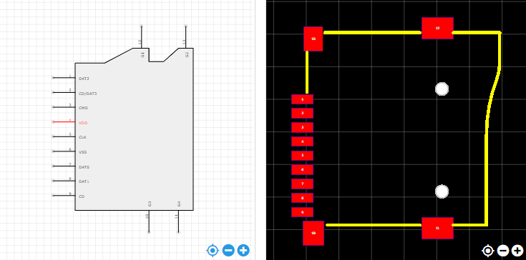
https://item.szlcsc.com/112422.html

